Equipment instructions

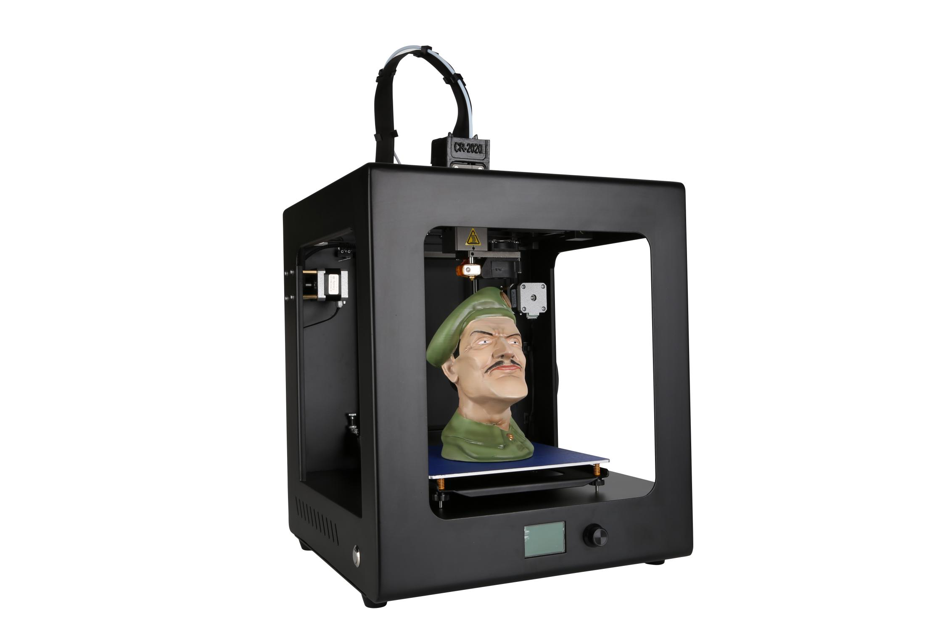operation manual

1. **Prepare before printing**

1. Connect the power supply, turn on the switch (connect the main switch at the power cord and the sub switch on the side of the machine), and install the rack;

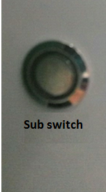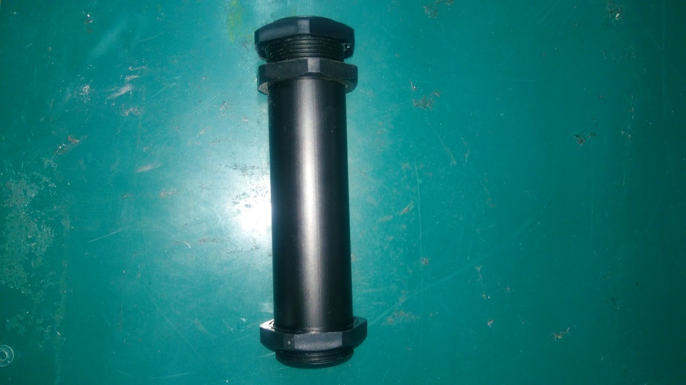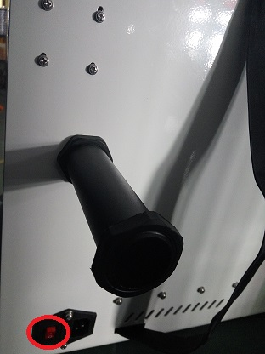

2. Feed (Note: 1, preheated nozzle before the feeding, click "Prepare" ☞ "Preheat pla", until the temperature is heated to the specified temperature, the consumables are sent to the feed gear, select " change filament ""loading")

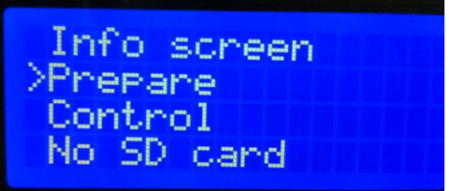

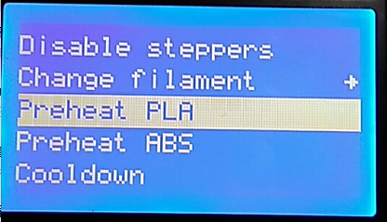

**Preheat the nozzle before feeding and retreating, quickly pull out the filament after the filament is withdrawn, otherwise the filament will block the nozzle.**

二、leveling the platform

when we use the utility knife to peel off the print from the print plate, the first layer of the next print may not stick after finishing printing. Apply a stick of solid glue on the tool box to the platform, depending on the size of the model you are printing.

Level the print plate

  1. Press the control knob to select "Prepare" -> "Leveling"

Main

Auto home

Moving axis

Disable steppers

**☞**Preheat PLA

Info screen

**☞** Prepare

Control

No SD card

2. After selecting the "leveling" command, according to the screen prompts, the nozzle will move to the four corners of the platform in order, horizontally observe the distance between the platform and the nozzle, and adjust the distance between the nozzle and the platform through the knob under the platform. Just can put A4 paper between them. After the adjustment, select "Auto- home" "Disable steppers" and when moving the nozzle manually, there are shallow scratches on the A4 paper.

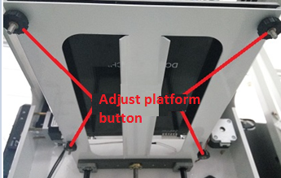

三、 install the slicing software and slice to generate an executable file (.gcode). For details, please refer to the installation instructions of the slicing software.

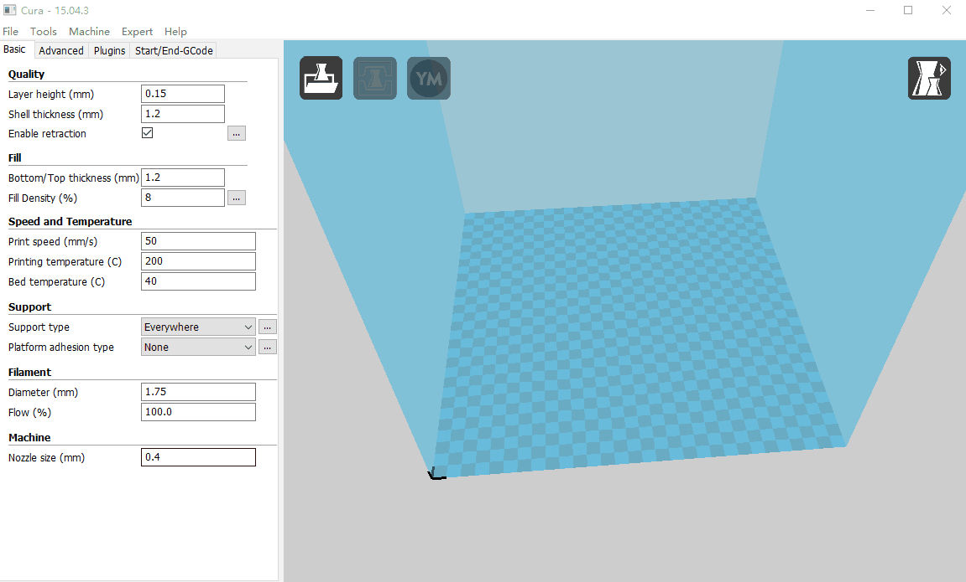

四、start printing

(1) Import the model you want to print into the slice software. After setting the parameters, click File - Save GCode to save the G code. Note that the file name cannot be Chinese or special characters.

(2) Before printing, transfer the G code of the model you want to print to the SD card, insert the SD card into the slot on the right side of the machine, and note the front and back sides of the card.

(3) Press the knob to enter the menu, select “print from SD”, find the file to be printed, press the knob to confirm, the nozzle starts heating automatically, and the preset temperature starts printing.

note:

1) Before printing, apply a textured paper on the print plate so that after finish printing, it will be easier to peel the print from the platform. Make sure the PLA supplies are sufficient to complete this print, otherwise replace the consumables before printing.

2) During the printing, the temperature of the nozzle reaches 205~210°C, and do not bring the body part or the flammable and explosive articles close to the spray head.

3) At the beginning of printing, see whether the consumables are tightly stuck on the platform. If there is no problem, they can leave; otherwise, please readjust the platform.

五、finish printing

   When the printing process is over, the machine will automatically shut down. next time you turn on the printer, what you need to do is booting with the sub switch. Be careful when removing the model from the platform. In order to facilitate the model, the hot bed can be heated to 50 for a while. When peeling the model, be careful not to damage the platform. After finish peeling, you can use the utility knife to clean the debris on the platform.